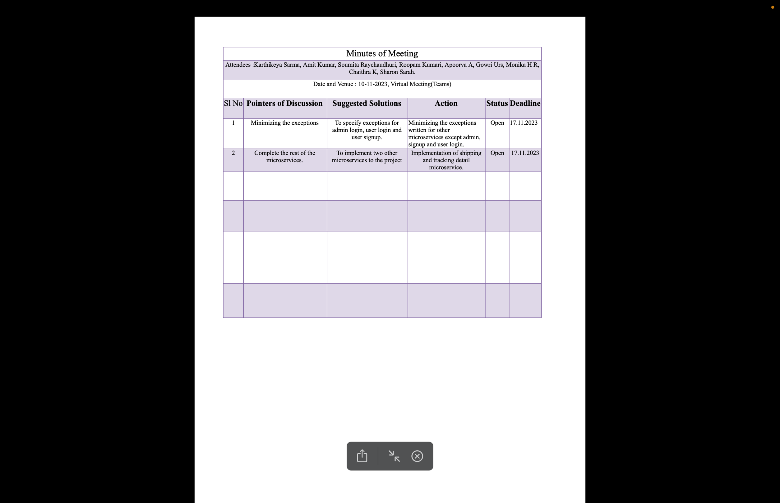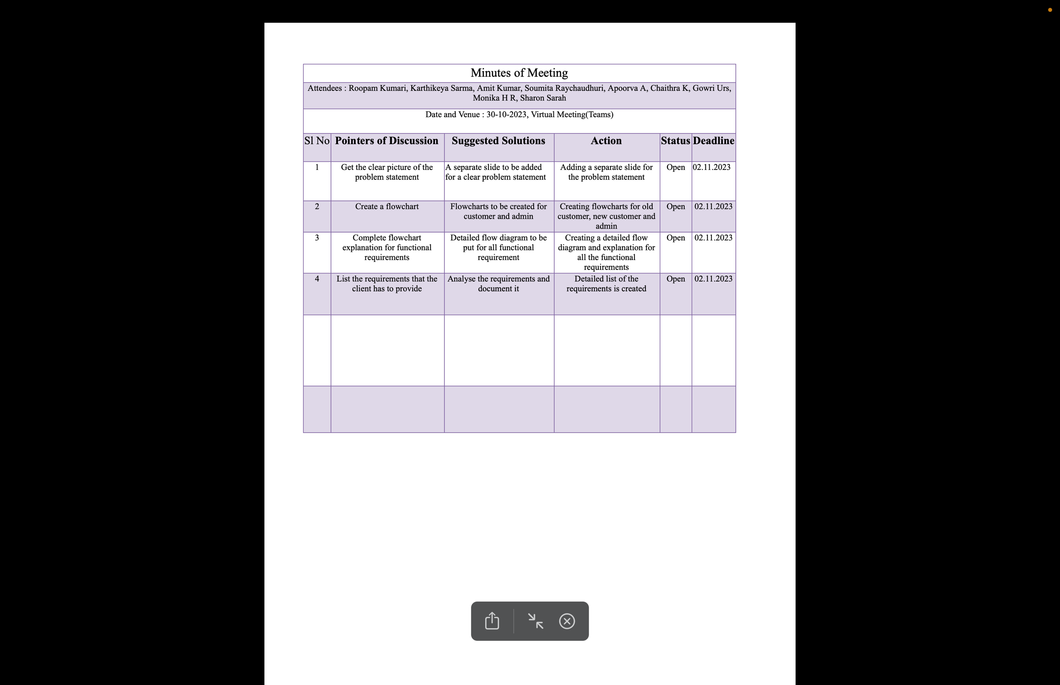**Minutes Of Meeting**

